Abstract—These instructions give you guidelines for preparing papers for proceedings of ICCSAM. Use this document as a template if you are using Microsoft Word 6.0 or later. Otherwise, use this document as an instruction set. Define all symbols used in the abstract. Do not cite references in the abstract. Do not delete the blank line immediately above the abstract; it sets the footnote at the bottom of this column.
Preparation of Papers for Proceedings of International Scientific Conference «Information and Computer Technologies, Modelling, Control»
First A. Author, Second B. Author, and Third C. Author

Index Terms—About four key words or phrases in alphabetical order, separated by commas.

Introduction
Highlight a section that you want to designate with a certain style, then select the appropriate name on the style menu. The style will adjust your fonts and line spacing. Do not change the font sizes or line spacing to squeeze more text into a limited number of pages. Use italics for emphasis; do not underline.
To insert images in Word, position the cursor at the insertion point and either use Insert | Picture | From File or copy the image to the Windows clipboard and then Edit | Paste Special | Picture (with “Float over text” unchecked).

Procedure for Paper Submission

Review Stage
Submit your manuscript electronically for review.

Final Stage
Deadline for a submission of the paper for publication: until October 5, 2015. Papers, represented after a deadline, will not be accepted by the program Committee. Submission of the paper for publication means that one of the co-authors should present a paper to the Conference.

Figures
As said, to insert images in Word, position the cursor at the insertion point and either use Insert | Picture | From File or copy the image to the Windows clipboard and then Edit | Paste Special | Picture (with “Float over text” unchecked).

Math
If you are using Word, use the Microsoft Equation Editor or the MathType add-on (http://www.mathtype.com) for equations in your paper (Insert | Object | Create New | Microsoft Equation or MathType Equation). “Float over text” should not be selected.

Hints

Figures and Tables
You need to position figures and tables at the top and bottom of each page. Large figures and tables may span the whole page. Place figure captions below the figures; place table titles above the tables. If your figure has two parts, include the labels “(a)” and “(b)” as part of the artwork. Please verify that the figures and tables you mention in the text actually exist. Do not put borders around the outside of your figures. Use the abbreviation “Fig.” even at the beginning of a sentence. Do not abbreviate “Table.” Tables are numbered with Roman numerals.
Do not use color unless it is necessary for the proper interpretation of your figures.
Figure axis labels are often a source of confusion. Use words rather than symbols. As an example, write the quantity “Magnetization,” or “Magnetization M,” not just “M.” Put units in parentheses. Do not label axes only with units. As in Fig. 1, for example, write “Magnetization (A/m)” or “Magnetization (Am⁻¹),” not just “A/m.” Do not label axes with a ratio of quantities and units. For example, write “Temperature (K),” not “Temperature/K.”
Multipliers can be especially confusing. Write “Magnetization (kA/m)” or “Magnetization (10³ A/m).” Do not write “Magnetization (A/m) × 1000” because the reader would not know whether the top axis label in Fig. 1 meant 16000 A/m or 0.016 A/m. Figure labels should be legible, approximately 8 to 12 point type.

TABLE I: The Arrangement of Channels
Channels | Group 1 | Group 2 | … | Group c

Main channel | Channel 1 | Channel 2 | … | Channel c
Assistant channel | Channel 2 | Channel 3 | … | Channel 1

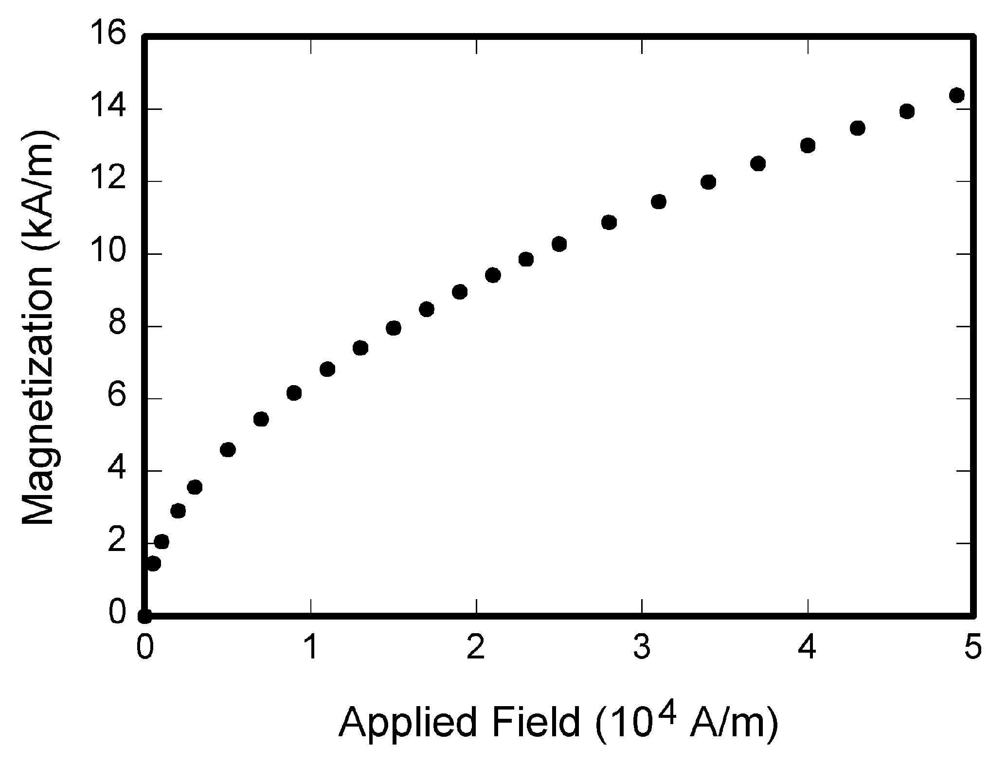
Fig. 1. Magnetization as a function of applied field.

References
Number citations consecutively in square brackets [1]. The sentence punctuation follows the brackets [2]. Multiple references [2], [3] are each numbered with separate brackets [1]–[3]. When citing a section in a book, please give the relevant page numbers [2]. In sentences, refer simply to the reference number, as in [3]. Do not use “Ref. [3]” or “reference [3]” except at the beginning of a sentence: “Reference [3] shows ... .” Number footnotes separately in superscripts (Insert | Footnote). Place the actual footnote at the bottom of the page in which it is cited; do not put footnotes in the reference list (endnotes). Use letters for table footnotes (see Table I).
Please note that the references at the end of this document are in the preferred referencing style. Give all authors’ names; do not use “et al.” unless there are six authors or more. Use a space after authors' initials. Papers that have not been published should be cited as “unpublished” [4]. Papers that have been submitted for publication should be cited as “submitted for publication” [5]. Papers that have been accepted for publication, but not yet specified for an issue should be cited as “to be published” [6]. Please give affiliations and addresses for private communications [7].
Capitalize only the first word in a paper title, except for proper nouns and element symbols. For papers published in translation journals, please give the English citation first, followed by the original foreign-language citation [8].

Abbreviations and Acronyms
Define abbreviations and acronyms the first time they are used in the text, even after they have already been defined in the abstract. Abbreviations such as SI, ac, and dc do not have to be defined. Abbreviations that incorporate periods should not have spaces: write “C.N.R.S.,” not “C. N. R. S.” Do not use abbreviations in the title unless they are unavoidable (for example, “JOURNAL OF ADVANCES IN COMPUTER NETWORKS” in the title of this article).

Equations
First, use the equation editor to create the equation. Then select the “Equation” markup style. Press the tab key and write the equation number in parentheses. To make your equations more compact, you may use the solidus ( / ), the exp function, or appropriate exponents. Use parentheses to avoid ambiguities in denominators. Punctuate equations when they are part of a sentence, as in

(1)

Be sure that the symbols in your equation have been defined before the equation appears or immediately following. Italicize symbols (T might refer to temperature, but T is the unit tesla). Refer to “(1),” not “Eq. (1)” or “equation (1),” except at the beginning of a sentence: “Equation (1) is...”.

Conclusion
A conclusion section is usually required. Although a conclusion may review the main points of the paper, do not replicate the abstract as the conclusion. A conclusion might elaborate on the importance of the work or suggest applications and extensions.
Appendix
Appendixes, if needed, appear before the acknowledgment.
Acknowledgment
The preferred spelling of the word “acknowledgment” in American English is without an “e” after the “g.” Use the singular heading even if you have many acknowledgments. Avoid expressions such as “One of us (S.B.A.) would like to thank ... ”. Instead, write “F. A. Author thanks ... ”. Sponsor and financial support acknowledgments are placed in the unnumbered footnote on the first page.
References
(Periodical style)
- S. Chen, B. Mulgrew, and P. M. Grant, “A clustering technique for digital communications channel equalization using radial basis function networks,” IEEE Trans. on Neural Networks, vol. 4, pp. 570-578, July 1993.
- J. U. Duncombe, “Infrared navigation—Part I: An assessment of feasibility,” IEEE Trans. Electron Devices, vol. ED-11, pp. 34-39, Jan. 1959.
- C. Y. Lin, M. Wu, J. A. Bloom, I. J. Cox, and M. Miller, “Rotation, scale, and translation resilient public watermarking for images,” IEEE Trans. Image Process., vol. 10, no. 5, pp. 767-782, May 2001.
(Book style)
- A. Cichocki and R. Unbehaven, Neural Networks for Optimization and Signal Processing, 1st ed. Chichester, U.K.: Wiley, 1993, ch. 2, pp. 45-47.
- W.-K. Chen, Linear Networks and Systems, Belmont, CA: Wadsworth, 1993, pp. 123-135.
- H. Poor, An Introduction to Signal Detection and Estimation; New York: Springer-Verlag, 1985, ch. 4.
(Book style with paper title and editor)
- R. A. Scholtz, “The Spread Spectrum Concept,” in Multiple Access, N. Abramson, Ed. Piscataway, NJ: IEEE Press, 1993, ch. 3, pp. 121-123.
- G. O. Young, “Synthetic structure of industrial plastics,” in Plastics, 2nd ed. vol. 3, J. Peters, Ed. New York: McGraw-Hill, 1964, pp. 15-64.
(Published Conference Proceedings style)
- M. B. Kasmani, “A Socio-linguistic Study of Vowel Harmony in Persian (Different Age Groups Use of Vowel Harmony Perspective,” International Proceedings of Economics Development and Research, ed. Chen Dan, pp. 359-366, vol. 26, Singapore: IACSIT Press, 2011.
- W. D. Doyle, “Magnetization reversal in films with biaxial anisotropy,” in Proc. 1987 INTERMAG Conf., 1987, pp. 2.2-1-2.2-6.
(Presented Conference Paper style)
- G. W. Juette and L. E. Zeffanella, “Radio noise currents n short sections on bundle conductors,” presented at the IEEE Summer Power Meeting, Dallas, TX, June 22-27, 1990.
(Thesis or Dissertation style)
- J. Williams, “Narrow-band analyzer,” Ph.D. dissertation, Dept. Elect. Eng., Harvard Univ., Cambridge, MA, 1993.
- N. Kawasaki, “Parametric study of thermal and chemical nonequilibrium nozzle flow,” M.S. thesis, Dept. Electron. Eng., Osaka Univ., Osaka, Japan, 1993.
(Patent style)
- J. P. Wilkinson, “Nonlinear resonant circuit devices,” U.S. Patent 3 624 12, July 16, 1990.
(Standards style)
- Letter Symbols for Quantities, ANSI Standard Y10.5-1968.
(Handbook style)
- Transmission Systems for Communications, 3rd ed., Western Electric Co., Winston-Salem, NC, 1985, pp. 44-60.
- Motorola Semiconductor Data Manual, Motorola Semiconductor Products Inc., Phoenix, AZ, 1989.
(Journal Online Sources style)
- R. J. Vidmar. (August 1992). On the use of atmospheric plasmas as electromagnetic reflectors. IEEE Trans. Plasma Sci. [Online]. 21(3). pp. 876-880. Available: http://www.halcyon.com/pub/journals/21ps03-vidmar

 Manuscript received October 9, 2001. (Write the date on which you submitted your paper for review.) This work was supported in part by the U.S. Department of Commerce under Grant BS123456 (sponsor and financial support acknowledgment goes here). Paper titles should be written in uppercase and lowercase letters, not all uppercase. Avoid writing long formulas with subscripts in the title; short formulas that identify the elements are fine (e.g., "Nd–Fe–B", "Cu-S-O4"). Do not write "(Invited)" in the title. Full names of authors are preferred in the author field, but are not required. Put a space between authors' initials. F. A. Author is with the National Institute of Standards and Technology, Boulder, CO 80305 USA (e-mail: author@boulder.nist.gov). S. B. Author was with Rice University, Houston, TX 77005 USA. He is now with the Department of Physics, Colorado State University, Fort Collins, CO 80523 USA (e-mail: author@lamar.colostate.edu). T. C. Author is with the Electrical Engineering Department, University of Colorado, Boulder, CO 80309 USA, on leave from the National Research Institute for Metals, Tsukuba, Japan (e-mail: author@nrim.go.jp).
It is recommended that footnotes be avoided (except for the unnumbered footnote with the receipt date on the first page). Instead, try to integrate the footnote information into the text.

